**Laporan Tugas 2**

**Praktikum Pemrograman 2**

**Fawwas Nawwaf Sabil 223040114**

**Repository :**

https://github.com/FawwasSabil25/PrakPro2_223040114.git

**Code & Penjelasan**

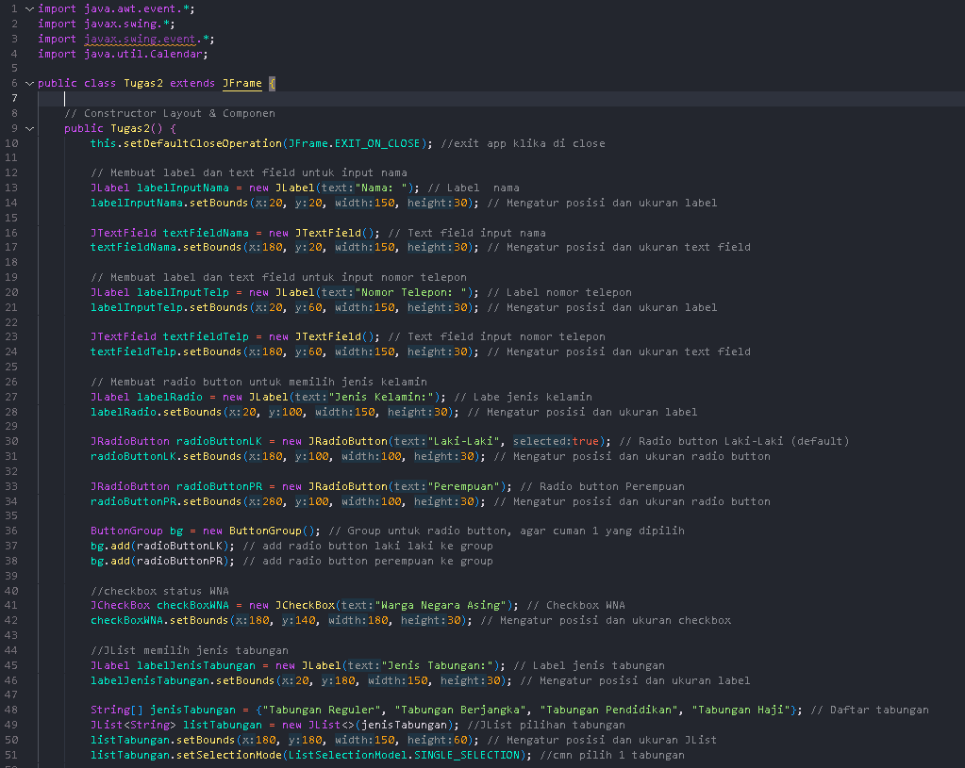

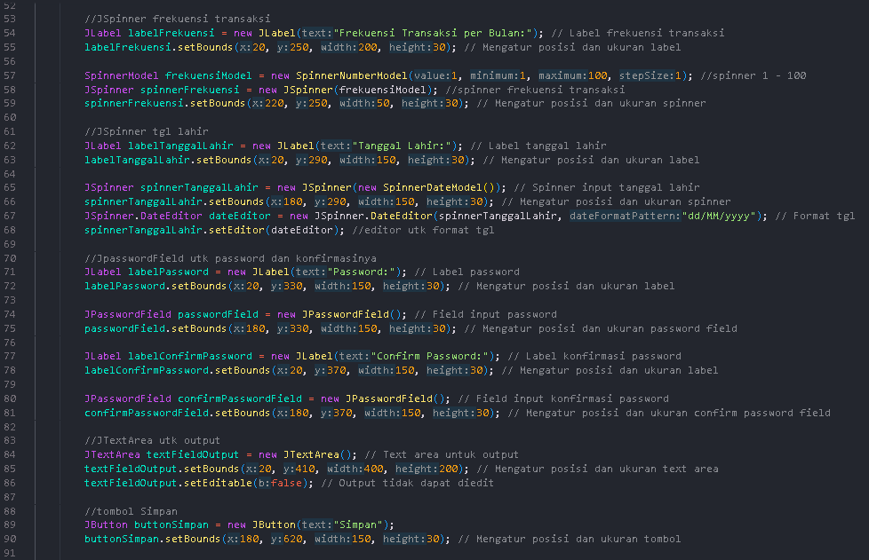

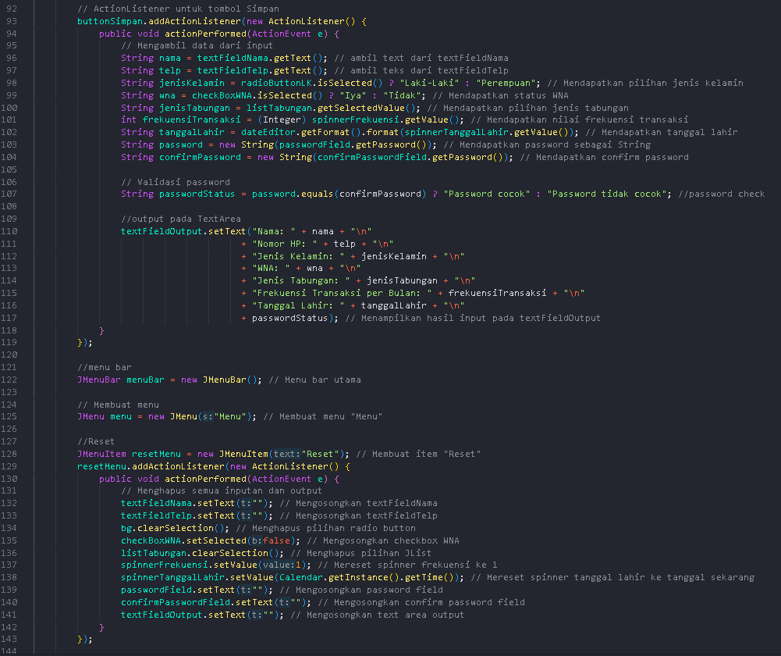

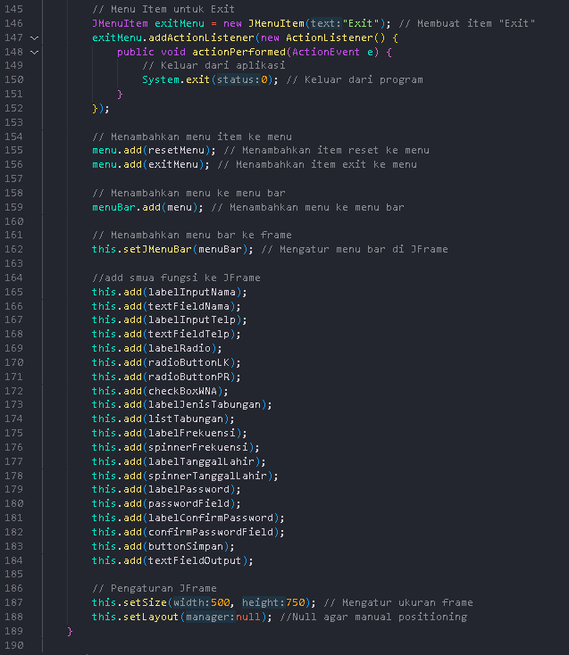

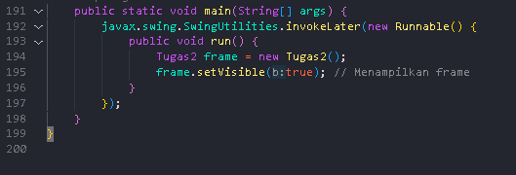

Hasil Run Code :

